CS460G: Machine Learning

Homework 1 Write-Up

Rupal Shah

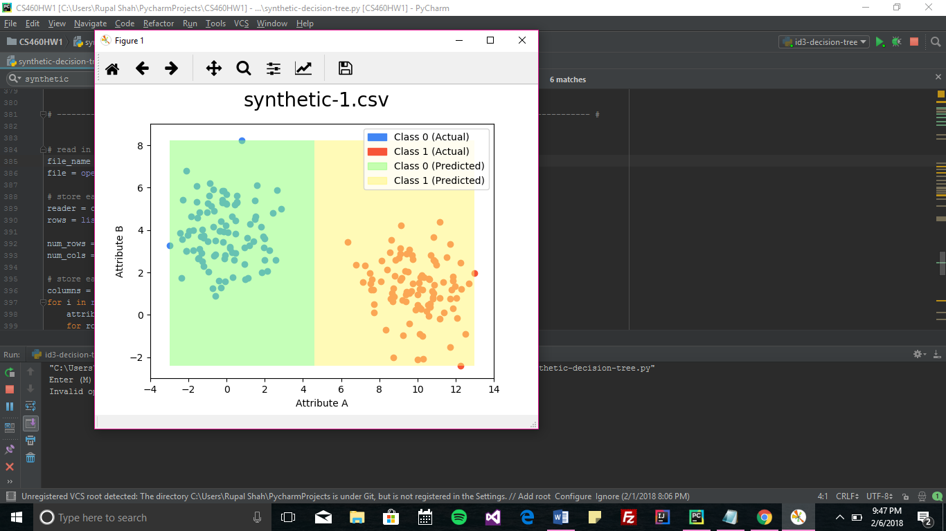

synthetic-1.csv error: 0.0%

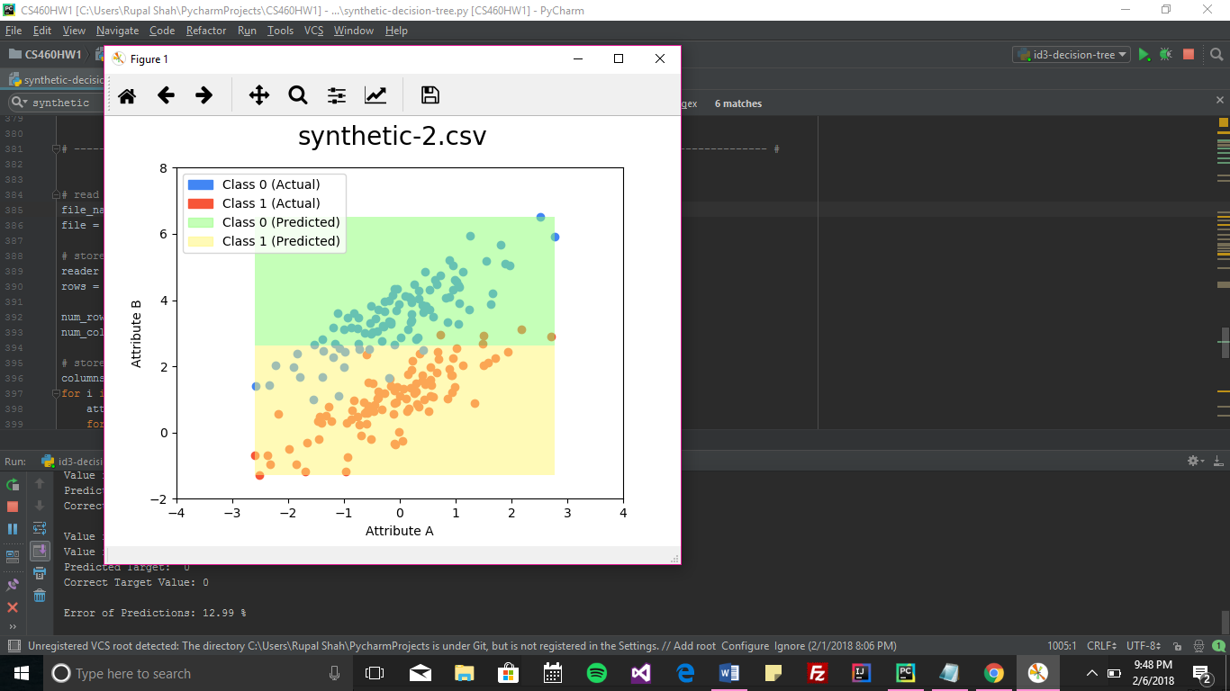  
synthetic-2.csv error: 12.99%

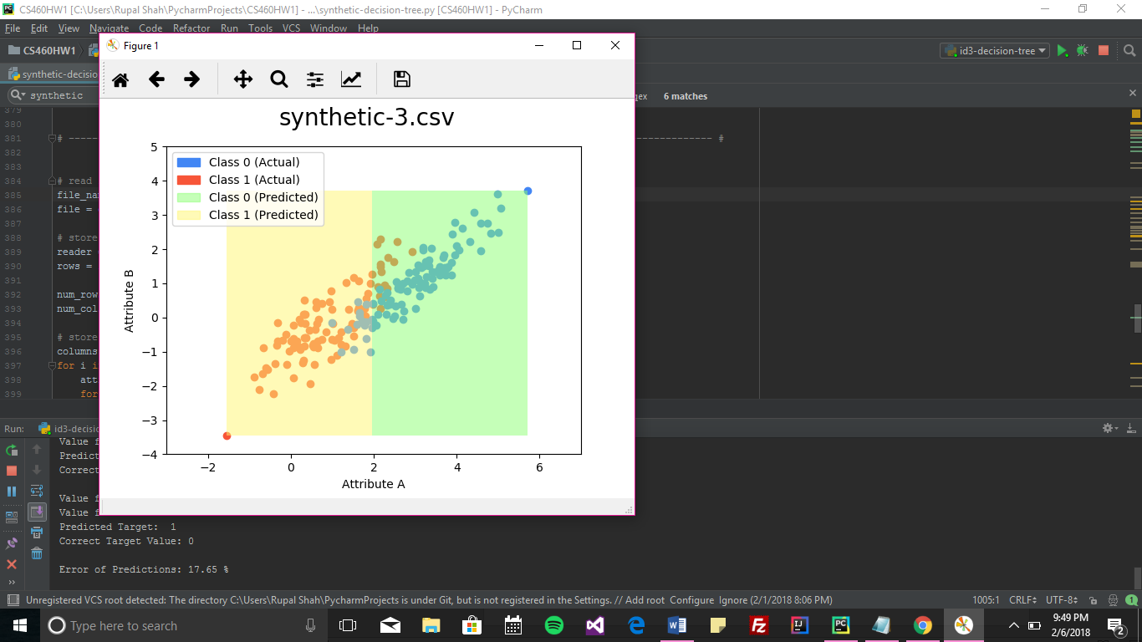  
synthetic-3.csv error: 17.65%

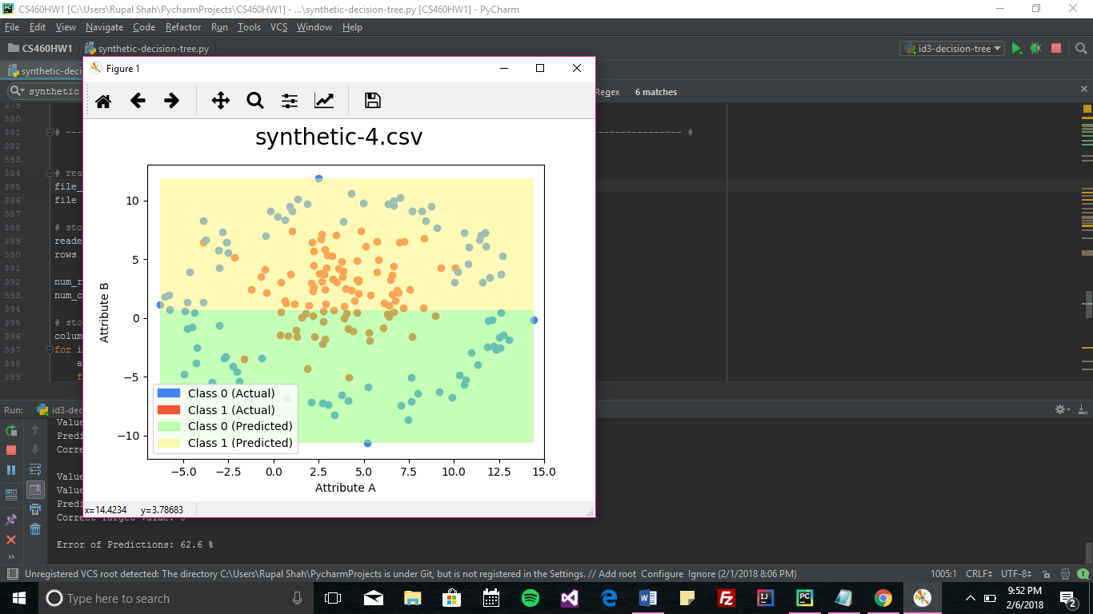  
synthetic-4.csv error: 62.6%